EnergyTrading MDM

MDM Admin Ui (sample)

|  |  |
| --- | --- |
| **Author** | RWE |

Release: Draft

Version: 0.1

Date: March 2014

1 Overview 3

1.1 The Tool 3

2 Concepts 4

2.1 Entities 4

2.2 Mappings 5

2.3 Lifespan 5

2.4 Temporal Entities 5

3 Menu & Icons 6

3.1 Menu UI 6

3.2 Menu Functions 6

4 Search 7

4.1 Entity Search 7

4.2 Mapping Search 8

4.3 Keyboard Shortcut Functions 9

5 Add/Edit/Delete Entities 10

5.1 Entity Details screen 10

5.2 Delete Entity 11

5.3 Referenced Entities 11

5.4 Referenced Entity Search UI 11

6 Add/Edit/Delete Mappings 12

6.1 Mapping Details screen 12

6.2 Delete Mapping 12

7 Navigation with Unsaved Changes 13

8 Status Bar 13

9 Entities 14

9.1 Broker 14

9.2 Exchange 14

9.3 Location 14

9.4 Party 15

9.5 Party Role 16

9.6 Person 16

9.7 Source System 16

10 Exceptions, Logging and Auditing 16

11 Configuration 18

11.1 Services 18

11.2 Service Colours 18

11.3 Help Document 18

11.4 Max Search Results 18

12 Example: New Gas Trader 19

# Overview

## The Tool

The MDM Admin Tool provides a User Interface (UI) over the Master Data Management (MDM) Service. The current version supports the following functionality:

* Add/Edit Entities
* Add/Edit/Delete Entity Mappings

The tool can be used administer any of the MDM services for which it is configured.

When the UI loads it displays the Search View. This enables the administrator to view a list of entities of the selected type which satisfy various filter criteria, and as of the specified date.

From the Search View, the administrator can edit an entity and its mappings. New entities of any type can be created at any time via the New menu item. It is not possible to delete an entity.

When adding or editing an entity it may have related entities. To specify a related entity they need to already exist.

Changes must be explicitly saved. When a request is made to navigate away from a page that has a new or edited entity or mapping a popup will appear warning that changes have not been saved.

All changes are audited in the database.

# Concepts

## Entities

The Entities that are supported by the sample version are:

* Broker
* Legal Entity
* Exchange
* Location
* Party
* Party Role
* Person
* Source System

## Mappings

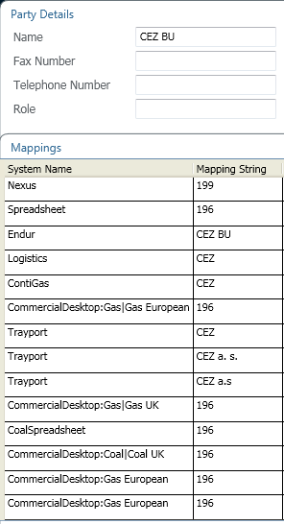

These specify the various names by which the entity is known in various systems

Nexus – M&E master name, database primary key

Spreadsheet – arbitrary internal name generated when data bulk loaded from spreadsheet

CommercialDesktop:*Desk* – arbitrary value, usually Nexus or Spreadsheet value, determines whether the entity is visible in Commercial Desktop for manual trades

Other eg Trayport, Endur – enables mapping of name from one system to another

## Lifespan

Both entities and mappings have a lifespan. Determines whether they can be used in enrichment and whether they are seen in the tool.

## Temporal Entities

The following applies to Party, Party Role and Person entities.

When a temporal entity is amended, the Start Date should be set to the effective date of the change. When the change is saved, the previous details will be retained in the database with an End Date of 1 second before the effective date of the change. Thus the state of the entity at a particular date can be seen by changing the tool’s AsOf date.

# Menu & Icons

Menu items are contextual. They may be disabled or enabled dependant on the state of the screen that is currently open. When a button is disabled it “greyed” such as the Navigate forward button shown in the Menu UI.

Select new entity type to create.

Navigate forward

Navigate back to Search view

## Menu UI

Access Help File.



Save any changes

Create a new entity/mapping

Navigate back

Select service to administer.

## Menu Functions

|  |  |  |
| --- | --- | --- |
| Select service | Select the service to administer. The tool restarts if the selection is changed. Services are colour-coded as a warning:   * d2 – Integration - Green * s2 – Test/Acceptance - Red * s3 – Test/Acceptance - Orange * p3 – Production - Gray * localhost – used by M&E developers only - Yellow |  |
| Search view | Navigates back to the Search view |  |
| Navigate Back | Navigates back to the previous page, disabled if no back page exists. | Ctrl + B |
| Navigate Forward | Navigates forward to a previous page, disabled if no forward page exists | Ctrl + F |
| Create New Entity/Mapping | Creates a new entity or mapping. The button is contextual so if viewing a search it will create a new entity of the type searched for. If viewing an entity it will create a new mapping for that entity. | Ctrl + N |
| Select New entity type to create | Allows you to select a new entity type to create ignoring the current context. |  |
| Save | After an entity or mapping is created/edited allow the changes to be saved to the server. | Ctrl + S |
| Help | The help button allows you to access this help file via Confluence. |  |

# Search

When the UI loads the default view is the Search View.

## Entity Search

Entity type selected from dropdown.

Searches are targeted at the Name field of the entity. The exceptions to this are:

* PartyCommodity is targeted at the Mapping Value field.
* Person, search is targeted at the Last Name field.
* Shipper Code, search is targeted at the Code field.

The search cannot contain wild cards, but searches within the string value. Leading/trailing space may be included. Search is not case sensitive.

Only entities whose lifetime includes the specified AsOf date are displayed.

Press Search (or ⮠) to perform search

So a search for Location with the value "gas" would return the results:

Search results

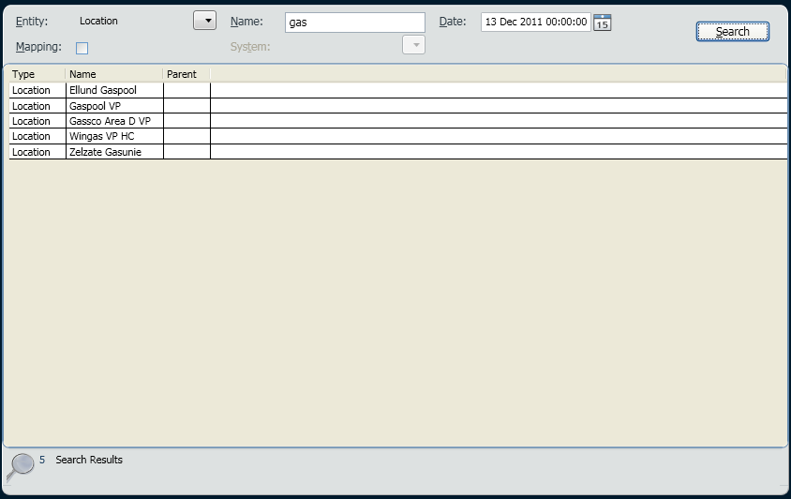

Submit search to the server

Number of search results returned

Search within validity range

Search term

Entity to search for

Searches are limited to a set number of results, a very round number of search results may indicate this.

All entity attributes are shown

Columns can be sorted by clicking on heading. Usually initially sorted on “Name”

Columns can be reordered and resized

Double-click an entity to edit it – displays the relevant Entity Details screen

## Mapping Search

Checking the Mapping box switches to searching on mapping value. Note that this search is case-sensitive:

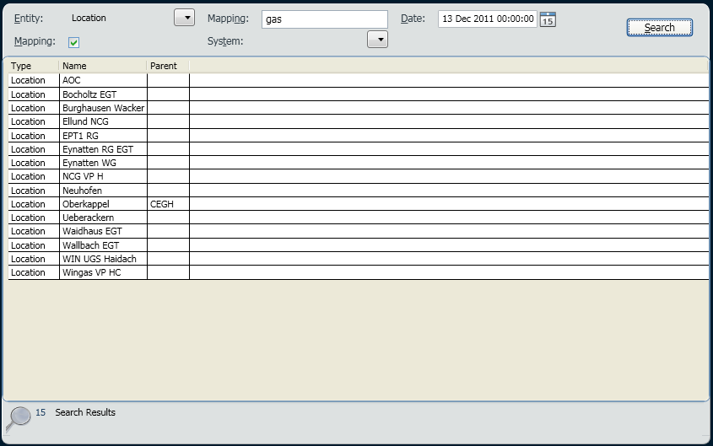

Specifying a System as well further restricts the results to entities which have that mapping value for that system:

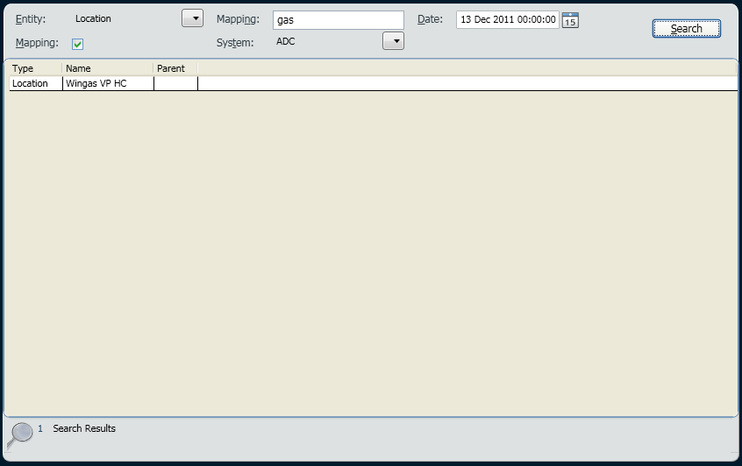

Specifying System but no Mapping value shows entities which have a mapping for that system:

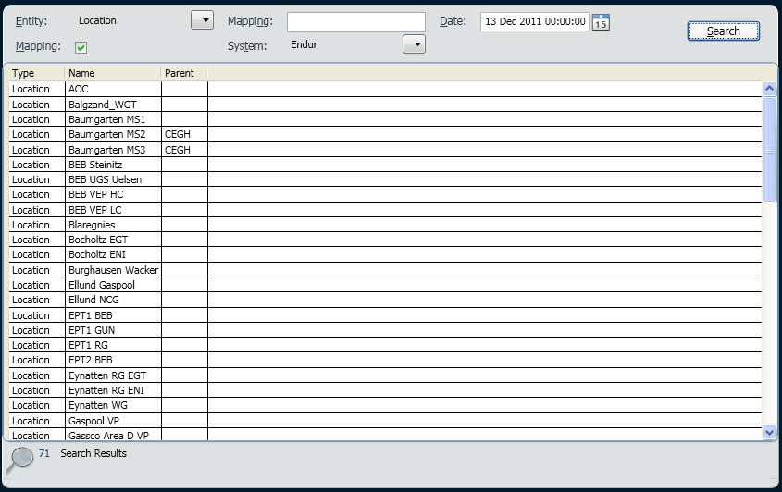

## Keyboard Shortcut Functions

|  |  |
| --- | --- |
| Focus Entity drop down | Alt + E |
| Focus “Name” text box | Alt + N |
| Focus Search button | Alt + S |
| Focus on Date drop down | Alt + D |
| Focus on Mapping checkbox | Alt + M |
| Focus on System drop down | Alt + T |

# Add/Edit/Delete Entities

To create an entity use the or icon. This displays a blank Entity Details screen



To edit an entity the user should search to locate the entity they are interested in and then double click the search result to display the Entity Details screen.

A entity’s mappings can be edited from its Entity Details screen

## Entity Details screen

An entity’s details screen shows all administrable attributes. Individual entities are described in detail later in this document.

Various tabs show associated entities and mappings. Tabs can be expanded/collapsed by clicking on the tab heading.

The Mappings tab shows all the entity’s mappings.

Other tabs are specific to the entity type and show other entities which reference the entity being edited.

An item in a tab can be double-clicked to view/edit it.

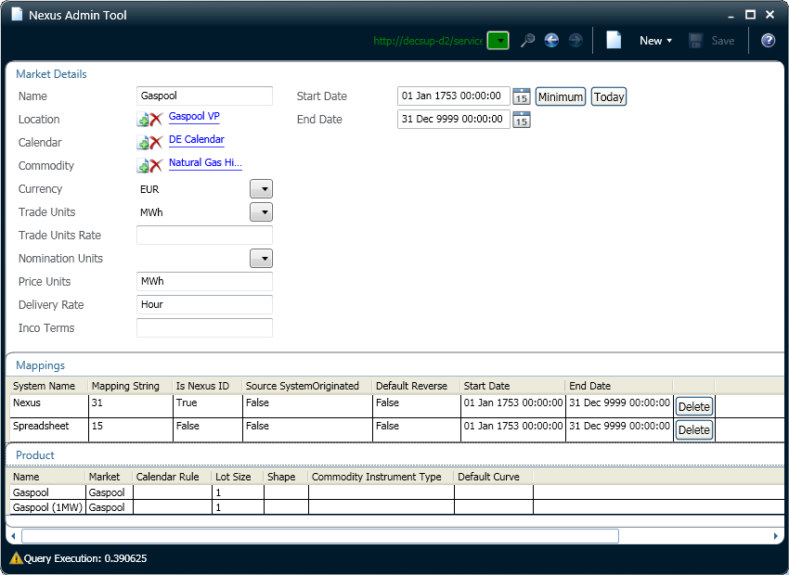

Use the icon to save any changes made. If creating a new entity, the screen will be redisplayed blank; if editing an existing entity, the entity is displayed.



The icon displays the Mapping Details screen



## Delete Entity

It is not possible to delete an entity. If an entity cannot be edited and it is no longer valid it should have its end date brought back to signal that it is no longer vaild in the current timeframe. This will mean that it is not returned in searches. E.g. for existing products a product would not be returned if its end date was before today’s date.

## Referenced Entities

An entity it may reference other entities. An example of this would be a Market being composed of a Location, Calendar and Commodity. Referenced entities must already exist.

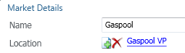

allows selection of an entity. The Referenced Entity Search screen is displayed



removes current entity



currently selected entity. Click to display Details screen to view/edit details



## Referenced Entity Search UI

When the user chooses to select a referenced entity (via ) the search screen will be displayed. The search works in the same way as a normal entity search, and the field that is searched on is noted in the Search section of this document.

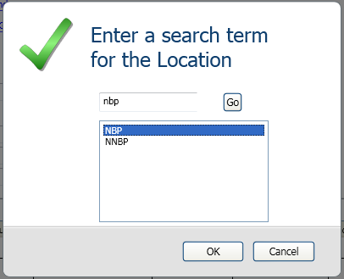

The user can type in a search term and click "Go". The results of the search will be displayed in the text area and a user can select a result and click "OK" to add the entity. By clicking “Cancel” the search will be cancelled and no entity selected.

# Add/Edit/Delete Mappings

To create a mapping for an entity use the icon from an entity’s details screen. This displays a blank Mapping Details screen



To edit a mapping double-click the item in the Mappings tab on the entity’s details screen.

## Mapping Details screen

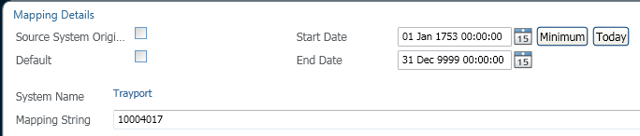

* Source System Originated – not currently used, leave False
* Default (True/False) – where an entity has multiple mappings for the same System, one of those mappings *should* be set True (but don’t try it at the moment!)
* System Name
* Mapping String – the name of the entity in the System
* Start Date & End Date (Date) – specifies the period for which the mapping exists. Mappings with lifespan which does not include the tool’s date are not visible unless the tool’s date is changed.

saves changes to mapping and returns to Entity Details screen



displays Mapping Details screen for new mapping



When editing a mapping it is important to understand that if the mapping string is changed a delete and then create will be issued to the server. This allows for other mappings to be tested for overlapping values. If there is a problem creating the new mapping then the old one will be recreated.

It is not possible to update the System Name for a mapping. If the system name is incorrect the mapping must be deleted and then recreated manually.

## Delete Mapping

A mapping can be deleted by clicking the delete button in the mapping grid on the entity details screen.

The Nexus mapping cannot be deleted.

# Navigation with Unsaved Changes

When a request is made to navigate away from a page that has a new or edited entity or mapping a popup will appear warning that changes have not been saved. The changes can be abandoned by clicking "OK", or the page can be re-activated to allow a save by clicking "Cancel".

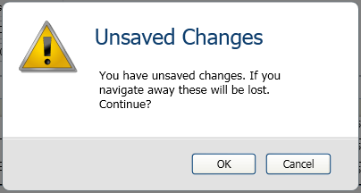

# Status Bar

When certain events occur they are reported in the status bar, which is located to the left of the bottom task bar, these events need no action, but allow the user to see when actions have completed. A common status message is shown below. This appears when a Person entity has been updated.

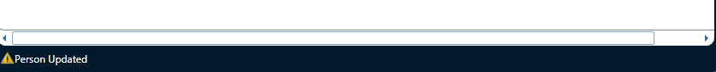

# Entities

Proper entities all have a ‘name’ – the master name, not necessarily how the entity is referenced in any particular system. Sometimes called something else.

Other entities are unnamed and represent relationships between other entities.

All have a Start Date & End Date – specifies the period for which the entity exists. Entities with a lifespan which does not include the tool’s date are not visible unless the tool’s date is changed.

## Broker

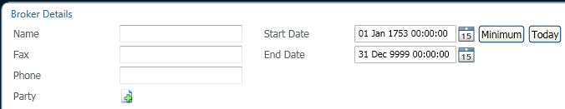

* Fax:
* Phone:
* Party:

## Exchange

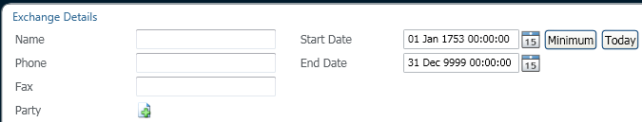

* Phone:
* Fax:
* Party:

## Location

Physical or virtual places, can be single eg. "Newcastle" or aggregate "Europe", forms a hierarchy

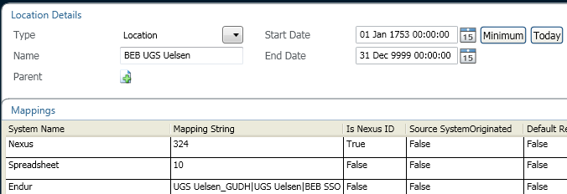

* Type: Location or Virtual Hub
* Parent:

Endur Mapping Value for Location comprises Location, Zone and Pipeline, pipe-separated

## Party

As new Parties start to trade then these will need to be updated by administrators. When a trade is enriched and we don't have a record of the Party then the details will need to be added. An exception will be emailed from the service in this case.

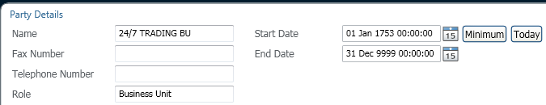

* Fax Number: optional
* Telephone Number: optional
* Role:

## Party Role

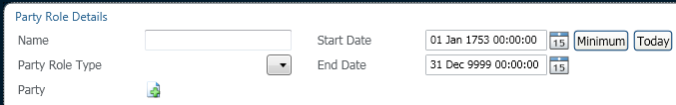

* Party Role Type:
* Party:

## Person

Generic entity which includes traders

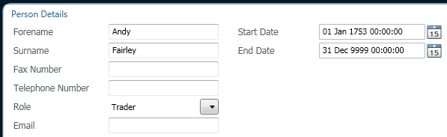

* Fax Number: optional
* Telephone Number: optional
* Role: Developer, Support, Tester or Trader
* Email:

## Source System

The list of source systems that M&E can map between

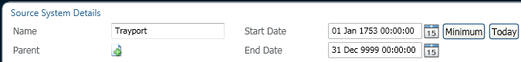

* Parent: not currently used, leave empty

# Exceptions, Logging and Auditing

All exceptions that are being raised by the MDM service and any unknown exceptions in the UI will be recorded in the log file. The log file can be found in the users local storage:

C:\Documents and Settings\{RE Number}\Application Data\RWE\NexusAdmin\

The log file is named: MdmAdmin.log.

Errors occurring in the MDM service will be displayed in the application. They can be dismissed by hitting enter or clicking the "OK" button.

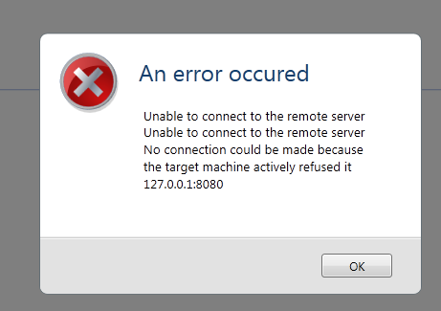

All database changes made via the admin tool are audited in the database.

There is no user interface to the auditing information.

# Configuration

The UI can be configured via the keys in App.config. This file is found in the root of the click once install directory.

## Services

The UI can be pointed to any deployed MDM services. The list provided to the administrator is defined by the “service” keys. Any key starting with “service” is added to the list. The key “service” is the default used when the UI starts:

<add key="service" value="http://decsup-d2/services/mdm/" />

<add key="service_s2" value="http://decsup-s2/services/mdm/" />

<add key="service_s3" value="http://decsup-s3/services/mdm_r1/" />

<add key="service_p3" value="http://decsup-p3/services/mdm_r1/" />

<add key="service_local" value="http://localhost:8080/" />

## Service Colours

The colours associated with the various services are defined by the “color” keys:

<add key="color_http://decsup-d2/services/mdm/" value="Green"/>

<add key="color_http://decsup-s2/services/mdm/" value="Red"/>

<add key="color_http://decsup-s3/services/mdm_r1/" value="Orange"/>

<add key="color_http://decsup-p3/services/mdm_r1/" value="Gray"/>

<add key="color_http://localhost:8080/" value="Yellow"/>

See <http://msdn.microsoft.com/en-us/library/ms976425> for valid colour names

## Help Document

Defines the location of the help document:

<add key="help_document" value="http://confluence.rwe.com:8081/download/attachments/66589764/Nexus+Admin+Tool.docx" />

## Max Search Results

The maximum number of entities returned by a search can be configured by changing the value for the key "maxSearchResults"

<add key="maxSearchResults" value="200"/>

# Example: New Gas Trader

* Request New Person entity

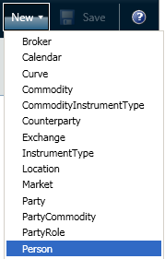

or (if already displaying list of Persons)



* New Person Details form displayed, supply trader’s details

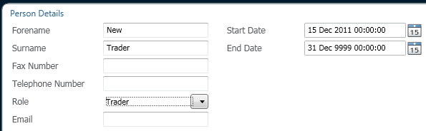

* Save, displays new Person Details form



* Back to Search screen



* Request list of Person entities

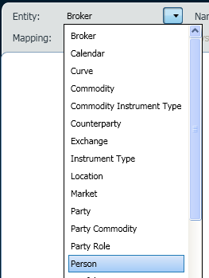

* List of Person entities, double-click to view/edit Details

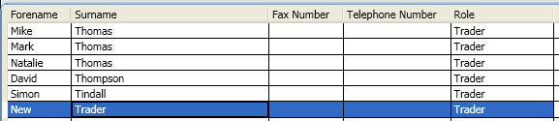

* Person Details form displayed

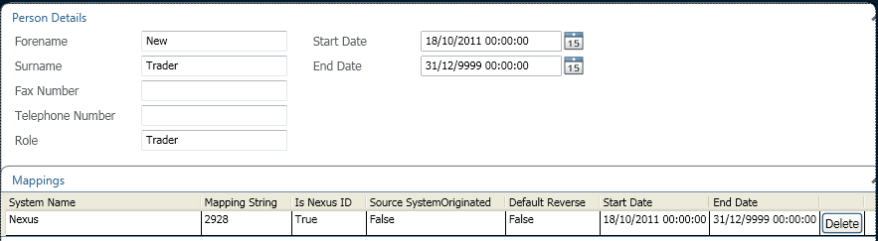

* Request New Mapping form



* New Mapping form displayed, specify desk as System, and trader’s name in that desk

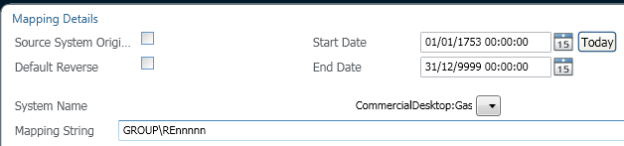

* Save, updated Person Details form displayed

